Task-1 Create a table listing 3 types of printers, 2 types of scanners, and 2 types of webcams, and for each, write one real-life use case (for example: 'Inkjet printer – printing college assignments').

Category | Device Type | Real-Life Use Case
Printer | Inkjet Printer | Printing color graphics, photos, and college assignments.
Printer | Laser Printer | Printing high-volume black-and-white office documents and business contracts.
Printer | Thermal Printer | Printing retail store checkout receipts and shipping barcode labels.
Scanner | Flatbed Scanner | Digitizing fragile vintage photo albums and pages from bound books.
Scanner | Sheet-Fed / ADF Scanner | Rapidly batch-scanning multi-page financial invoices and tax documents.
Webcam | USB Desktop Webcam | Attending remote university lectures and daily video conference calls.
Webcam | PTZ (Pan-Tilt-Zoom) Webcam | Broadcasting professional hybrid boardroom meetings or live-streaming events.

Task-2 Draw a labeled diagram showing how a typical home printer connects to a laptop or PC, including the connection interface used (USB, Wi-Fi, or Bluetooth).

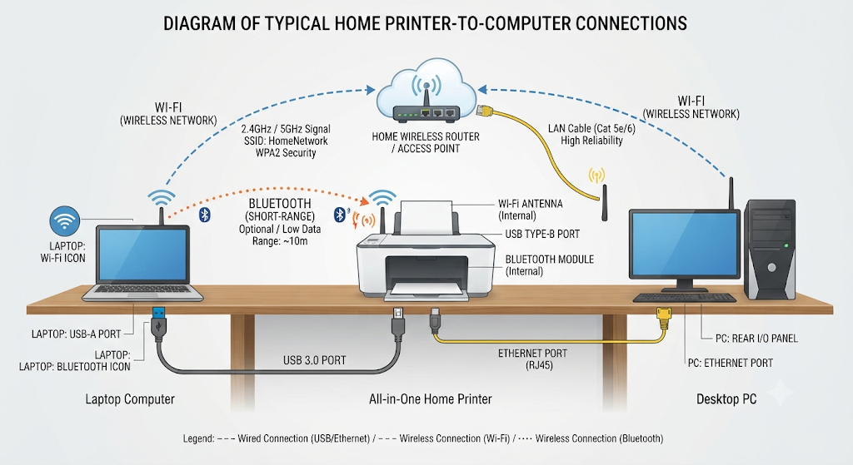

Task-3 List three different connection interfaces (such as USB, Wi-Fi, Bluetooth) used by peripherals like printers, scanners, and webcams, and for each, name one advantage and one disadvantage.Hint: Think about speed, convenience, and compatibility.

Here are three common connection interfaces used by peripherals like printers, scanners, and webcams, along with an advantage and disadvantage for each:

1. USB (Universal Serial Bus)
- Advantage: Provides a fast, stable, and highly reliable wired connection that is immune to wireless signal interference or dropouts.

- Disadvantage: Lacks mobility and requires a physical cable, limiting where you can place the peripheral relative to your computer.

2. Wi-Fi (Wireless Network)
- Advantage: Offers complete placement flexibility and wireless convenience, allowing multiple computers and mobile devices on the same network to share the peripheral from anywhere in the room or office.

- Disadvantage: Setup can occasionally be complex, and connections are susceptible to network congestion, interference, or signal drops.

3. Bluetooth
- Advantage: Simple, straightforward device pairing and low power consumption for short-range wireless connectivity.

- Disadvantage: Low data transfer bandwidth and a limited operating range (typically around 10 meters), making it unsuitable for high-bandwidth devices like webcams or large print jobs.

Task-4 Pick any one device you use at home or college (printer, scanner, or webcam). Write step-by-step instructions for how you would connect it to your computer, including what cable or wireless method you would use and any setup steps required.
Step 1: Unboxing and Powering On
- Action: Unpack the printer, remove any protective blue tape or packing materials from the paper trays and ink cartridge area, and install the ink cartridges according to the manufacturer's manual.

- Action: Plug the power cord into the back of the printer and plug the other end into a standard wall outlet, then press the Power button to turn it on.

Step 2: Connecting the Printer to Your Wi-Fi Network
- Action: Using the printer's built-in LCD control panel or touchscreen, navigate to the Settings, Network, or Wi-Fi Setup menu.

- Action: Select Wi-Fi Setup Wizard, choose your home or college Wi-Fi network SSID from the list, and enter your network password using the keypad or on-screen keyboard.

- Result: Once connected, the printer's Wi-Fi indicator light will turn solid, indicating it is successfully joined to your wireless network.

Step 3: Adding the Printer on Your Computer
- For Windows:

  - Open Settings > Bluetooth & devices > Printers & scanners.

  - Click on Add device. Windows will automatically scan your local network for available printers.

  - When your printer model appears in the list, click Add device.

- For macOS:

  - Open System Settings > Printers & Scanners.

  - Click the Add Printer, Scanner, or Fax button (or the + icon).

  - Select your printer from the network list and ensure the driver/protocol is set to AirPrint or the corresponding manufacturer software. Click Add.

Step 4: Installing Companion Software and Drivers (Optional but Recommended)
- Action: Go to the manufacturer's official support website (e.g., HP, Canon, Epson) and download the recommended driver or companion app (such as HP Smart).

- Action: Run the installer on your computer. This unlocks advanced features like direct scanning, ink level monitoring, and specialized photo printing presets.

Step 5: Print a Test Page
- Action: Open a sample document or college assignment PDF on your computer, press Ctrl + P (or Cmd + P on Mac), select your newly installed printer from the dropdown menu, and click Print.

- Result: If the document prints cleanly and clearly, your wireless printer setup is complete and fully operational!

